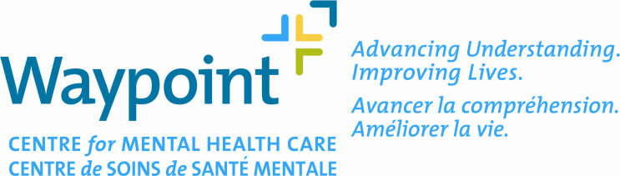

Local Serious Adverse Event (SAE) Report

Submission:
Complete this report for each adverse event, sign it and submit to the REB along with the more detailed reports of the event(s) provided to the external study sponsor (if any). Submit 2 additional copies to the REB Office who will determine whether further review is required or not. The REB will acknowledge receipt of this SAE submission.

Reporting Timeline:
48 hours for Fatal/Life Threatening SAEs
10 business days for Non-Fatal SAEs

- REB #: Protocol Title:

- Sponsor Name:

- Principal Investigator:

- Person Completing the Form:
Phone #: Fax #: Date Submitted:

- Investigational Drug/Device/Intervention:

- Data Safety Monitoring Board: Yes or No

- Participant Code/SAE Identifier:

- Onset Date of SAE: Resolution Date of SAE:

- Event Type: Initial Follow-up Final

- Medical Term for SAE:

- Patient Outcome
(1=Fatal; 2=Hospitalization; 3=Medical Intervention; 4=Recovered; 5=Ongoing; 6=Other (Specify):

- Study Action
(1=None; 2= Dose Adjusted; 3= Discontinued from Study; 4=Other (specify):

- Causal Relationship to Study Intervention
Definitely/Probably Related
Possibly Related
Unlikely/Unrelated
Events that are ‘Not Serious’, ‘Not Related’, or are ‘Expected’ do not need to be reported to the REB

- Does the SAE require a change to the Protocol? Yes or No:

- Does the SAE require a change to the Consent Form? Yes or No:

Amended Protocol and/or Consent form should be submitted to the REB.

16. Summary of SAE:

The signature attests that the Principal Investigator reviewed the SAE and the safety implications of the study and attests to the accuracy of the information.

____________________________ ________________________
Signature of the Principal Investigator Date (yyyy/Mmm/dd)

SUBMIT COMPLETED FORM TO:

Glenn A. Robitaille, M.Div., D.Min., RP
Chair, Research Ethics Board
Waypoint Centre for Mental Health Care
500 Church Street,
Penetanguishene, ON L9M 1G3
Email: grobitaille@waypointcentre.on.ca
Phone: 705-549-3181, Ext. 2216
Fax: 705-549-3652

Local Serious Adverse Event (SAE) Report

(This box to be completed by the Local Principal Investigator)

REB Project #: Locally Responsible Investigator:

Title of Study:

Event #:

REVIEW BY AD HOC PHARMACIST REPRESENTATIVE
(This box to be completed by the Research Ethics Board Ad Hoc Pharmacist Representative)

[] Further review is NOT required by the REB
[] Further review is required by the REB

COMMENTS:

________________________________________ _____________________________
Signature of REB AD Hoc Pharmacist Date

FURTHER REVIEW OF ADVERSE EVENT BY REB
(This box to be completed by REB Chair only for projects requiring further review)

Recommendations:
Protocol change: [] YES [] NO
Consent Form change: [] YES [] NO

Description of Changes Required:

Final Disposition by Research Ethics Board following further review:
[] Approved for continuation
[] Approved conditional on changes
[] Suspended pending further review

____________________________________ _________________________
Signature of Chair, Research Ethics Board (OR Designate) Date

